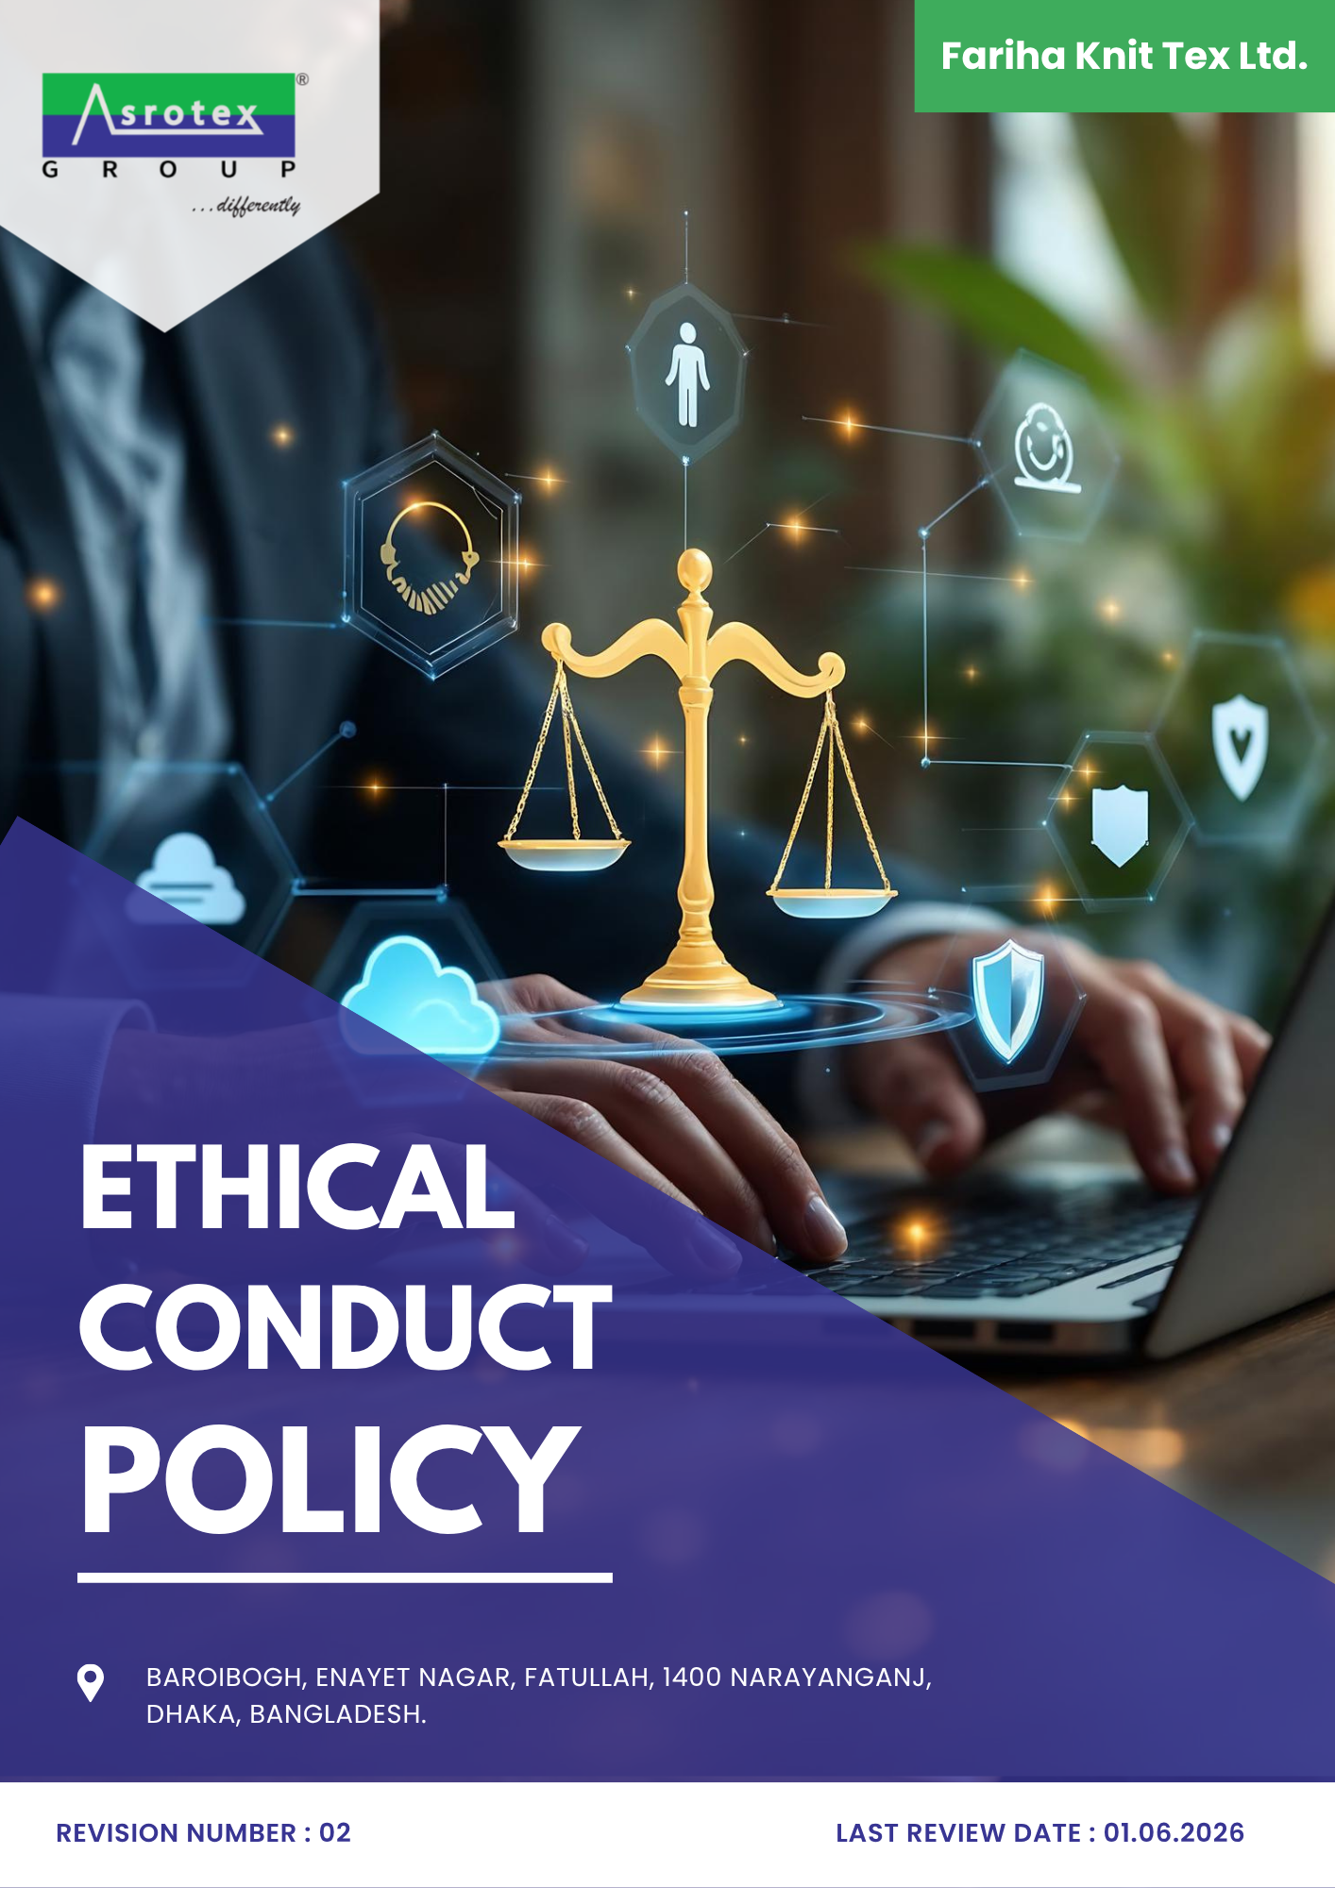

INDEX

PREFACE 3
SCOPE 3
POLICY DECLARATION 3
INITIATIVES AND TARGETS 4
CONTINUOUS IMPROVEMENT 6
RESPONSIBILITIES 7
CONSEQUENCES OF POLICY VIOLATIONS 7
REVIEW MECHANISM 8
Annexure A : Examples and Guidance for Ethical Business Practices 9
EMPLOYEE ACKNOWLEGEMNT 11

PREFACE

Fariha Knit Tex Ltd. is committed to conducting its business with the highest standards of integrity, ethics, transparency, and accountability. As a responsible textile manufacturer, we believe that ethical business practices are fundamental to sustainable growth, stakeholder trust, and long-term business success. This Ethical Conduct Policy establishes the principles and standards that guide the conduct of our directors, employees, contractors, suppliers, and other business partners in all business activities.
The Company maintains a zero-tolerance approach towards bribery, corruption, fraud, money laundering, conflicts of interest, anti-competitive behaviour, and any other form of unethical or unlawful conduct. We are committed to complying with all applicable legal requirements, internationally recognized ethical standards, and customer expectations while fostering a culture of honesty, fairness, respect, and responsible decision-making

SCOPE

This Policy is applicable to following sites and all of its employees, workers, sub-contractors and other stakeholders:

Sr. No. | Site | Address
1 | Fariha Knit Tex Ltd. | Baroibogh, Enayet Nagar, Fatullah, 1400 Narayanganj,  Dhaka, Bangladesh.

POLICY DECLARATION

Fariha Knit Tex Ltd. is committed to conduct all business operations in an ethical, honest, and transparent manner. This policy establishes our standards for preventing unethical practices such as corruption, bribery, fraud, conflict of interest, and money laundering, both within our company and across our supply chain.

All employees, suppliers, and stakeholders are expected to adhere to these ethical principles and act with integrity in all their interactions. Compliance with applicable laws and regulations is a fundamental requirement, and any violations of this policy should be promptly reported through the designated channels. By enforcing this policy, Fariha ensures that ethical conduct is embedded into the fabric of our operations, fostering an environment of trust, accountability, and responsible business practices. Year 2022 serves as the baseline year to assess the effectiveness and progress of our ethical conduct measures.

INITIATIVES AND TARGETS

- Corruption
- To maintain zero-tolerance approach to corruption in all business dealings, ensuring compliance with national and international anti-corruption laws and foster a corporate culture of integrity where employees and suppliers actively reject corrupt practices.
- Ensure continuous training for employees on identifying and preventing corruption-related activities.
- Maintain a 100% compliance rate in anti-corruption audits across all departments by 2030.
- To implement anti-corruption due diligence procedures for 100% of high-risk business partners by 2030.

- Conflict of Interest

- Promote transparency in all procurement and business relationships to prevent conflicts of interest and implement a clear, accessible process for reporting and addressing potential conflicts of interest.
- Ensure 100% of key employees and suppliers sign conflict of interest declarations by 2030.
- Ensure that 100% of new hires complete conflict-of-interest training within their first month of employment.

- Fraud
- To maintain an independent internal audit team to review fraud investigations and ensure accountability and transparency in resolving cases.
- Regularly review and update fraud prevention training materials to ensure they address emerging risks and trends in the industry.
- Achieve a target of 90% employee participation in fraud prevention training by 2030, ensuring employees are equipped with the knowledge to detect and prevent fraudulent activities.
- To implement fraud prevention and detection controls across 100% of high-risk business processes by 2030.

- Money Laundering
- To continuously implement measures to identify, prevent, and report suspicious transactions related to money laundering activities.
- Ensure all employees and suppliers comply with applicable anti-money laundering (AML) regulations and practices by conducting regular AML audits and assessments
- Ensure that 100% of employees complete AML training by 2030 to maintain awareness and compliance.

- Anti-Competitive Practices
- To promote fair competition and ensure that all business practices are in line with anti-trust laws.
- Encourage transparency in pricing, procurement, and market strategies to avoid unfair competitive practices.
- Ensure 100% of suppliers adhere to anti-competitive practices clauses in their contracts by 2030.

- Responsible Information Management
- Promote a company-wide culture of data security awareness and responsibility.
- Ensure 100% encryption and implementation of protective measures for sensitive data by 2030.
- Continuously monitor and improve data protection practices to safeguard sensitive information.
- Maintain zero data breaches and security incidents by implementing robust security protocols and preventive measures, ensuring continuous improvement.
- Achieve 100% employee training on data privacy and responsible information management by 2030.

- Whistleblowing & Non-Retaliation
- Maintain a confidential, accessible whistleblowing channel through which employees, workers, and suppliers can report suspected violations without fear of retaliation.
- Strictly prohibit retaliation of any kind against anyone who reports a genuine concern in good faith, with disciplinary action for any employee found retaliating.
- Achieve 100% awareness of the whistleblowing channel among employees and key suppliers by 2030, verified through periodic surveys.

ALIGNMENT WITH SDGs

CONTINUOUS IMPROVEMENT
At Fariha Knit Tex Ltd., we are committed to continuously improving our ethical practices and maintaining the highest standards of integrity across all operations. We regularly assess and update our policies, procedures, and systems to ensure they are effective in preventing unethical conduct, fraud, and violations. This includes enhancing employee training programs, improving detection systems, and incorporating feedback from stakeholders. By fostering a culture of continuous improvement, we aim to uphold trust, minimize risks, and ensure ethical conduct in all our business dealings.

RESPONSIBILITIES
- Compliance Officer: Ensures the implementation and adherence to ethical conduct policies, including anti-corruption, fraud prevention, conflict of interest, anti-money laundering, and information security.
- HR Manager: Oversees employee training on ethical conduct, ensuring compliance with relevant policies.
- IT Manager: Protects sensitive company and customer data, ensuring compliance with data protection regulations.
- Internal Audit Team: Conducts regular audits to assess compliance, identify risks, and recommend corrective actions.

CONSEQUENCES OF POLICY VIOLATIONS
Failure to comply with this Ethical Conduct Policy may result in disciplinary action in accordance with the Company's applicable policies, procedures, and legal requirements. The nature of the disciplinary action will depend on the severity, frequency, and impact of the violation.
Disciplinary measures may include, but are not limited to:
- Verbal or written warning.
- Mandatory corrective actions or retraining.
- Suspension from duties or responsibilities.
- Termination of employment or contractual relationship.
- Recovery of losses or damages, where permitted by law.
- Referral to relevant regulatory or law enforcement authorities, where required.
Any employee, contractor, supplier, or business partner found to have engaged in unethical conduct, fraud, corruption, retaliation against whistleblowers, or any other violation of this Policy may be subject to the appropriate disciplinary or contractual action.

REVIEW MECHANISM

This policy will undergo an annual review by the Compliance Officer to ensure its continued relevance and effectiveness. Regular audits will be carried out, and key performance indicators (KPIs) will be used to monitor compliance. Employee and stakeholder feedback will be gathered through surveys and grievance mechanisms, and management will address any concerns identified, implementing improvements as necessary.
This framework ensures that Fariha Knit Tex Ltd. remains committed to high ethical standards in alignment with Bangladeshi laws, regulations, and global best practices.

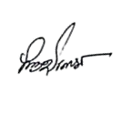
REV. No. 02


LAST REVIEW DATE: 01.06.2026 NEXT REVIEW DATE: 01.06.2027
APPROVED BY: M Shohidul Islam

Revision History

Rev. No. | Review/Effective Date | Description of Changes | Approved By
00 | 01.06.2024 | Initial Issue
01 | 01.06.2025 | Annual policy review and update.
02 | 01.06.2026 | Initiatives and Targets topic, Annexure A added

Annexure A : Examples and Guidance for Ethical Business Practices

No. | Topic | Illustrative Example | Expected Guidance
1 | Corruption | During a supplier evaluation, an employee is offered expensive gifts or personal benefits in exchange for awarding a contract. | Employees must refuse such offers, avoid any improper influence on business decisions, and promptly report the incident through the Company's reporting channels.
2 | Conflict of Interest | An employee participates in selecting a supplier owned by a relative or close associate without disclosing the relationship. | Any actual, potential, or perceived conflict of interest must be disclosed immediately. The individual should withdraw from the decision-making process until the conflict has been appropriately managed.
3 | Fraud | An employee intentionally falsifies invoices, inventory records, working hours, or expense claims for personal gain. | Company records must accurately reflect all business transactions. Any suspected fraud must be reported immediately and will be investigated in accordance with Company procedures.
4 | Money Laundering | A customer or supplier requests payment through an unrelated third party, multiple small transactions, or an overseas account without a legitimate business reason. | Employees should exercise due diligence, identify unusual financial activities, and report suspicious transactions before processing them in accordance with AML procedures.
5 | Anti-Competitive Practices | During an industry event, competitors discuss future prices, customer allocation, production volumes, or market-sharing arrangements. | Employees must not participate in discussions that may restrict fair competition. They should leave the discussion immediately, document the incident, and notify the Compliance function.
6 | Information Security | Confidential customer information or business documents are stored on personal devices, shared through unauthorized platforms, or accessed without approval. | Confidential information must only be accessed, stored, and transmitted using approved Company systems. Any suspected cybersecurity incident or data breach must be reported immediately.
7 | Whistleblowing & Non-Retaliation | An employee suspected misconduct | The employee must report through the whistleblower procedure. Company protects individuals who raise concerns in good faith. Retaliation of any kind is strictly prohibited, and all reports will be handled confidentially, impartially, and without prejudice.

EMPLOYEE ACKNOWLEGEMNT

I, the undersigned, acknowledge that I have received, read, and understood the Ethical Conduct Policy of Fariha Knit Tex Ltd. I agree to comply with the policy's provisions, including the company’s commitment in maintaining the highest ethical standards in all business operations and refraining from involvement in corruption, bribery, fraud, conflicts of interest, money laundering, or any other unethical conduct.

I understand that any violation of this policy may lead to disciplinary action, including termination of employment or business relationships, and may involve legal consequences if necessary. I also acknowledge my responsibility to report any violations or suspicious activities to the appropriate authority within the company.

By signing below, I reaffirm my commitment to upholding the integrity and ethical standards of Fariha Knit Tex Ltd. in all my professional actions.

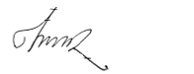
Name: Md. Moshedul Faraji
Position: Senior Operator, Sewing
Signature: ______________________
Date: 05-06-2026

